Q8.) List out the different states in Life Cycle of a Thread?

->

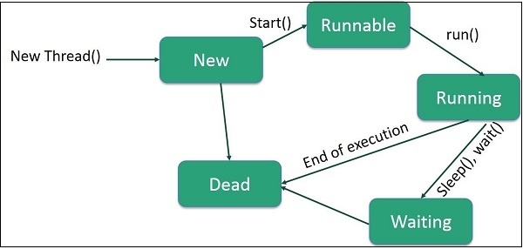

Following are the stages of the life cycle −

* **New**− A new thread begins its life cycle in the new state. It remains in this state until the program starts the thread. It is also referred to as a born thread.
* **Runnable** − After a newly born thread is started, the thread becomes runnable. A thread in this state is considered to be executing its task.
* **Waiting**− Sometimes, a thread transitions to the waiting state while the thread waits for another thread to perform a task. Thread transitions back to the runnable state only when another thread signals the waiting thread to continue executing.
* **Timed Waiting** − A runnable thread can enter the timed waiting state for a specified interval of time. A thread in this state transitions back to the runnable state when that time interval expires or when the event it is waiting for occurs.
* **Terminated (Dead)**− A runnable thread enters the terminated state when it completes its task or otherwise terminates.